**LAB 4- EC2 Ubuntu Instance install JDK and setup JAVA_HOME path environment variable**

**Step 1: Connect to Your EC2 Instance via putty**

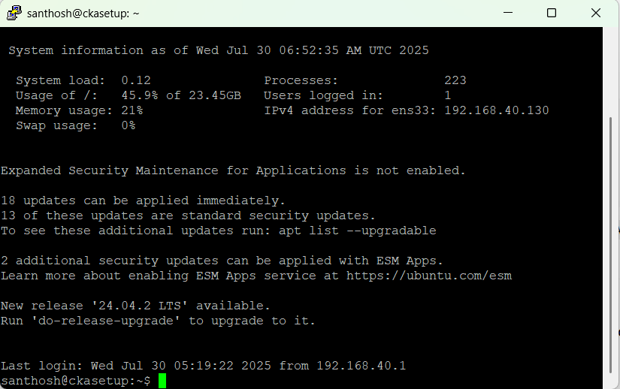

**Step 2: Update the Package Manager**

Update your package lists to ensure you get the latest versions:

**sudo apt update**

**Step 3: Install OpenJDK**

**sudo apt install openjdk-11-jdk -y**

**Step 4: Verify Java Installation**

**java –version**



**Step 5: Find where Java is installed**

**readlink -f $(which java)**

**Outcome: /usr/lib/jvm/java-17-openjdk-amd64/bin/java**



**Step 6: JAVA home path will be**

**/usr/lib/jvm/java-17-openjdk-amd64**

**Step 7:** **Set JAVA_HOME environment variable**

**export JAVA_HOME=/usr/lib/jvm/java-17-openjdk-amd64**

**export PATH=$PATH:$JAVA_HOME/bin**

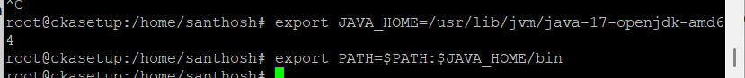

**Step 8: Set JAVA_HOME permanently (recommended)**

**sudo nano /etc/profile**

**Scroll to the bottom and add:**

**export JAVA_HOME=/usr/lib/jvm/java-11-openjdk-amd64**

**export PATH=$JAVA_HOME/bin:$PATH**

**Now reload the profile:**

**source /etc/profile**

**Verify:**

**echo $JAVA_HOME**

**Step 9: final check**

**java --version**

**echo $JAVA_HOME**